Plantar Fasciitis Stretching Exercises

Routine Stretching is very important to healing plantar fasciitis. Most of those affected by plantar fasciitis have decreased flexibility and tight Achilles Tendons.

Towel Stretch

Sit on the floor with your legs stretched out in front of you. Loop a towel around the top of the injured foot. Slowly pull the towel towards you keeping your body straight. Hold for 15 to 30 seconds then relax – repeat 10 times.

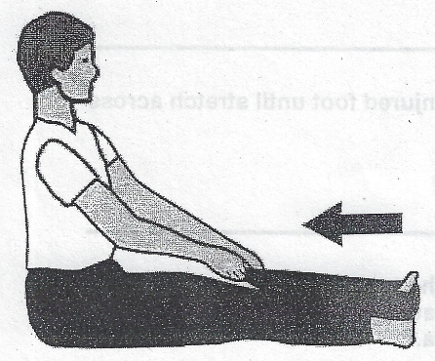

Calf/Achilles Stretch

Stand facing a wall and place your hands on the wall chest high. Move the injured heel back with the foot flat on the floor and toes pointing toward the wall. Move the other leg forward and slowly lean toward the wall until you feel a stretch through the calf. Hold and repeat. Stretch both sides.

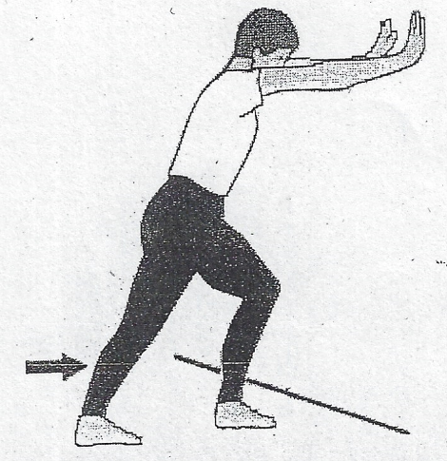
Stair Stretch

Stand on a step on the balls of your feet, hold the rail or wall for balance. Slowly lower the heel of the injured foot to stretch the arch of your foot and Achilles tendon.

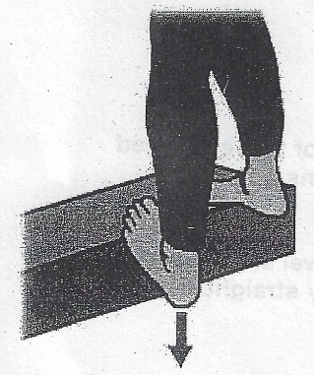

Frozen Can Roll

Roll your bare injured foot back and forth from the tip of the toes to the heel over a frozen water bottle or can. This is a good exercise after activity because it not only stretches the plantar fascia but provides cold therapy to the injured area.

